Web 2.0 Tools for the Educator
IWLA Technology Workshop
Saturday October 8, 2011
1:30-2:55 & 3:05-4:30

Animoto
Makes photo slide shows with music. Free version allows you to make free 30 second videos. You can use your own music or theirs. I have used this to show cultural events like Day of the Dead and Quinceañera. I have also used it in the clothing unit while students were working on their fashion show.
STEPS:
- Go to: www.animoto.com
- At the top of the webpage click sign up. (Or Sign In if you already have an account)
- Click the grey/blue “Try now” button under the lite circle. This is the free account.
- Fill out the “Create an Account” page and hit ENTER
- Click the teal colored “Get Started” button.
- In the right hand corner, click the teal colored “Create Video” button.
- Pick a video style. First view the video by double clicking on the video rectangle that interests you. If it has a red pro circle in the right hand corner it is not free. A larger rectangle will open and click the arrow to view the video style. When you find the one you like click the teal colored “create video” under the video and then click the make 30 second video (under the teal colored “purchase video” button. OR if you are on the view screen you do not need to click the teal colored “create video” under the video simple click the make 30 second video (under the teal colored “purchase video” button.
- On the left hand side of the page click the Add Pics & Vids button. Decide where you’re getting your pictures. Click one of the options (computer, facebook…etc) Once you’ve found your pictures click the add button. You can use video too, but it will only give a total of 30 seconds of pictures and video combined.
- You can delete, add, move and rotate pictures. Put them in the order you’d like to have them. (Free account allows about 12 pictures) Spotlight allows the video to stay longer on a favorite picture. If you use spotlight, you may not be able to have all 12 pictures in your slideshow. Duplicate allows you to duplicate a favorite picture and have it in your slideshow more than once.
- Click the “Choose Music” button. You can upload your own music from your computer or choose from their music. If you use their music, pick the category you’d like. If you’d like to preview the song click the blue arrow on the left hand side when the song title is highlighted.
- If you want you can use the text button to add text, but it counts as one of the 12 photos.
- When your video is done or you need to stop working on it click the green “Produce Video” button.
- Wait a few minutes or until you receive an email from animoto telling you your video has been produced. To view the video follow the instructions in the email OR click the “My Videos” button at the top of the webpage. You can play it by clicking the blue arrow on the left hand side.
- Highlight the Untitled Project. A green “Actions” button will pop up on the right hand side of the webpage. This button will allow you to continue working on your project (remix), delete it, download it, export it and more. Click “Rename.”
- Name it what you would like and save it. You can use the “Embed” button to post it to a website or blog.

- Quinceañera example: http://dc-gspanish.yolasite.com/7th-grade.php
- Fashion show examples:
http://dc-gspanish.yolasite.com/fashion-show-7th-grade.php
http://dc-gspanish.yolasite.com/fashion-show-2011-qrt-3.php
Fotobabble/Voicethread
Photo presentation with the ability to record and re-record voice. This worked great for the clothing unit fashion show. Fotobabble works best with only 1 picture. Voicethread has the ability to use multiple pictures.
STEPS:
- Go to: www.fotobabble.com
- Click the orange “Sign up” button on the top right hand corner of the webpage. (Or Sign In if you already have an account.) Set up your account and click “Sign up.”
- Choose a photo from your computer or other means. Click the “Create” button.
- Pick a theme. This will give your picture a border.
- Record your voice. Must click “allow,” “record,” and then “stop.” To listen to it click, “play.” If you don’t like it-start this step over.
- If a student is making this to share it with you-it must be marked “public.”
- Fill out the picture title and give it any tags that you wish.
- Click “Save.”
- To view, click “view this fotobabble,” in the yellow box below the save button. OR at the top of the webpage click “My Fotobabbles.” and click the picture. Here you can edit the photo or share it by embedding it or using the link provided.
- To make another click the orange “Create your own” button or the button at the top of the webpage that says, “Create a Fotobabble.”

STEPS:
- Go to: www.voicethread.com
- Click the grey “Sign In or Register” button at the top right hand corner of the webpage.
- Click “Register” button, fill out form and click “Register” (Or Sign In if you already have an account)
- Click the grey “Create” button.
- Upload your pictures, images or video from any of the given sources.
- Add a title and description by clicking, “(Add a title and description).” Click save.
- Rotate, Order and delete pictures as desired. Add a title and link for each picture is desired.
- Click “Comment” button. You can choose to upload a picture to identify the speaker (upload it), do it later (I’ll do it later), or leave it blank all together (Close X).
- Click “Comment” button to record voice. You can use your phone to record voice, webcam, microphone or type what you want said. To record, click “record.” Click “allow.” Begin talking.
- Listen to your recording (It will automatically replay for you.) If you like it click “save”, if you don’t click “cancel,” if you want to add more click “record more.”
- To advance to another slide use the arrows to move from picture to picture. Repeat steps 9 and 10 for every picture.
- The rectangles under every picture tells you how many recordings each picture has.
- To listen to your project use the play button under the picture.
- If you want to delete a recording-While it is playing click the trashcan. Confirm the deletion by clicking, “delete it.”
- In order to share the project you must have it marked as public. To do this, at the bottom of the page click the “Publishing Options” button. Mark “anyone to view.”
- After watching the slide you have some options. These options are also found at the bottom of the webpage. You can send the project via email, get an embed code to put it on a website or blog, and get a link to share with others.

- Fashion show example (Voicethread):
http://dc-gspanish.yolasite.com/fashion-show-2011-qrt-3.php

Glogster
Why Blog if you can Glog? Creates an online poster. Works great for students to record facts they’ve learned.
STEPS:
- Go to: http://www.glogster.com/
- Use the following directions to create a Glog:

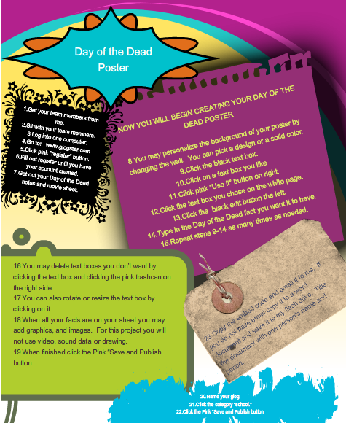

- You can also use command, shift, 4 to take a screen shot of the poster to save and print it.

- Day of the Dead examples:
http://dc-gspanish.yolasite.com/day-of-the-dead-poster-6th-grade.php

Voki
Talking avatar. Can speak or type what avatar says. Avatar can be posted to any blog, website or profile. I used this to make a Guess Who game for my Spanish I class. You can use it to teach/give instruction. Students can have their own personal avatar and use it to complete text activities or have conversations.
STEPS:
- Go to: www.voki.com
- Click the orange “Register” button. (Or Login if you already have an account)
- Create your Voki account. Use an email address you can access today-an activation link will immediately be sent there once you fill out the for and click “Sign Up.”
- Go to your email, wait for the voki email, and follow the directions in the email.
- Once back on the website. Click the “Create” button to begin making your avatar.
- Use the “background” and “player” button to design the initial look for your voki.
- Begin designing your avatar by using the customize your character buttons. Here many options are available to you. Play around and search the different categories until you find just the right one for you. (You can click the “dice” button to be given a voki at random.)
- You can change the placement, color and size of features using the “tweak” and “color” area below the voki. The magnifying glass in the corner of the player allows you to change the size and position of the avatar.
- Next, make your avatar talk by using one of the “give it a voice” options. You can record your voice by phone, microphone, or another audio source on your computer. You can also type what your avatar will say.
- If you type what it will say you can use the FX tab to add sound effects to your voice recording. You can also choose an accent and a voice to read your text. To preview it, click the play button under your text. You can edit and change anything you didn’t like. When finished click the green “done” button.
- Now you’re ready to save your avatar. Click the “publish” button at the bottom of the screen. Title this avatar or scene and click save.
- The next page that pops up will allow students to send you their project. To publish student work students can send you the embed code and you can use that to place it on a website or blog. Students can also directly email their work to you.
- All the avatars that you create will be saved under the “My Voki” tab. It is here that you can continue to create more, view, delete or change the ones you have using the “edit” button.
- The best thing I like about this is, once the students have sent you the embed code and you have their work published the first time, when they change their avatar there is no need to resend the codes. The changes are automatically tied to the original code. This allows me to give them a new avatar assignment and deadline and after that deadline I can check their avatar online. Students can work on their avatar from any internet source.

- Guess Who game: http://dc-gspanish.yolasite.com/guess-who-u1e2.php
- Student examples: http://dc-gspanish.yolasite.com/voki-spanish-i.php
- Teacher example: http://dc-gspanish.yolasite.com/spanish-i.php

Cacoo
Website that allows you to make online diagrams. I used this to have students make their family tree. I’ve also made a library layout and a phone tree.
STEPS:
- Go to: www.cacoo.com
- Click large green “Sign Up! Get a Free Account!” button. (Or Sign In if you already have an account)
- Fill out form and click “create.”
- Click the pink “Create New Diagram” button.
- Specific steps from here are independent of what you want to create. The stencil box is what you will use to find images. Click on the category you would like and the images will show up below. If you don’t see the images you may need to make the box bigger. Click the image you want and drag it to the white spacein the desired area. 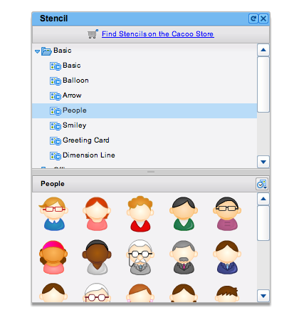
- If you click “Find Stencils on the Cacoo Store” you will be able to find a large variety of free images you can use in addition to the ones they provide in the stencil box. Find the image you want. Double click on it. Click the pink “Purchase single license” button. (To ensure it is free it should cost 0 points.) Now the icons are available for your use and you can drag the ones you desire to your project in the desired area of the white area.
- The buttons at the top of the page allow you to undo, redo, copy, paste and cut. The button with the “A” lets you write text on the white area. The next button allows you to draw lines. (I used this a lot in the family tree project.) There are other buttons here. The best thing is to experiment using these buttons.
- The free version does not let you export your document, but there is a cool way around this. Click “save.” Fill out the title, write a description if you choose. Check it to public and copy the link. Students can email this link to their teacher and teachers can view their work. Click “Ok.”
- When you go back to the cacoo site, you will see your diagram saved along with some other examples. If you’d like to edit it, click this button: The presentation will open another webpage where you can work on the presentation.
- If you would like students to print their presentation they should go to the cacoo site and double click on their diagram. When it is open they can take a screen shot of the project using command, shift, 4. This will take a picture of the poster. It can then be dragged into Word and change the size. Students can save, print and even email this to the teacher.
- Another way the project can be shared is to go to the cacoo site and double click their diagram. Once the diagram is open there will be some buttons at the top of the screen. Click the “Link” button.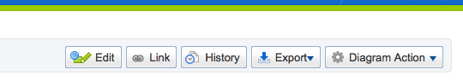
- Here you can get the URL code or the embed code. Students can email this to the teacher and the teacher can use these codes to publish the student’s work online.

- Family Tree examples: http://dc-gspanish.yolasite.com/family-tree-8th-grade.php

----------------------

Password protected Excel spreadsheet
Allows you to save your passwords and usernames for all your accounts in one location so you never forget what they are. It is password protected so no one else can have access to it.

STEPS:
- Create a new spreadsheet.
- Go to the menu and choose “Excel>Preferences.”
- Then click on “Security” on the next screen.
- Fill in your passwords, either to open, modify or both.
- Click “okay.” Your password protected spreadsheet is created.

IF WE HAVE TIME…..

Cartoons
*Comic strips with lots of options: http://www.toondoo.com/
STEPS:
- Go to the above website.
- Sign up for free or log in.
- Click “Create” and choose your layout by double clicking on the desired layout.
- Use the top blue colored buttons to see images by category. When you find the image you want, drag it into the white space provided. This is where you also find text boxes to write text. If you want to write in the target language, you can use the typeit website to type the accents easily and then paste them into the cartoon.
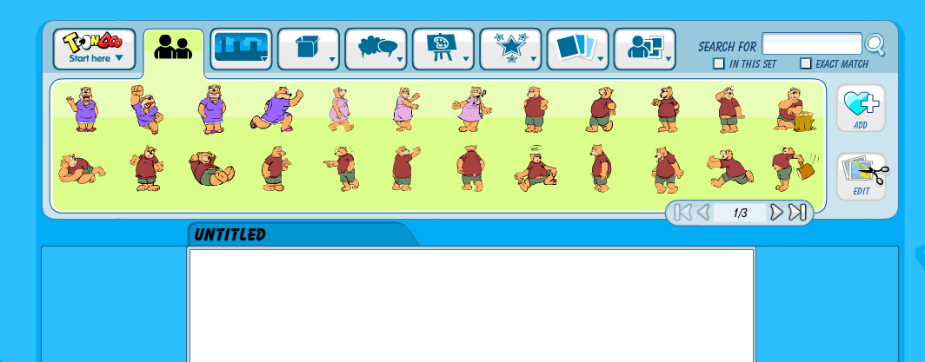
- Use the buttons at the bottom of the white space to edit and change images. When you are finished use the “Toondoo” button at the top of the screen to save your cartoon. (See image under Step #4.) Create a title, description and tag and click “publish.” Student should click “publish to the world” so the teacher is able to see it. After it is published the cartoon can also be printed to turn in to the teacher. Later this cartoon can be viewed or edited by going to the “Toondoo” button and clicking “open.”
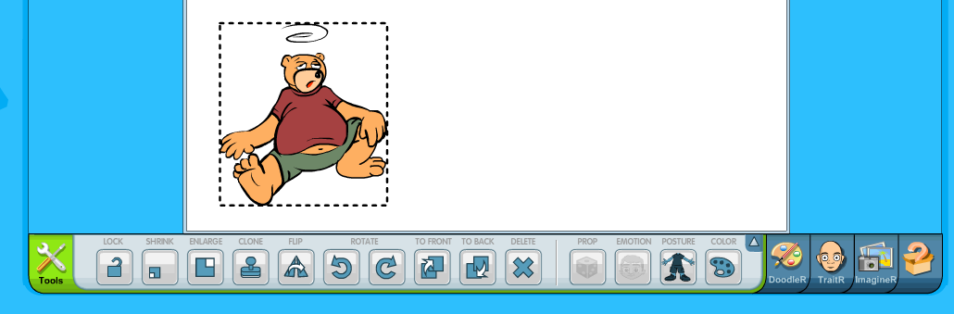

*Easy and Fast Comic strips with limited options. Allows you to type in many languages: http://www.makebeliefscomix.com/
STEPS:
- Click the “Bird man” to view a demo. Use the arrow buttons to read/view the demo.
- Click “Enter Here.”
- Start making your comic according to the demo.
- When saving the cartoon can be e-mailed or students can take and save a screen shot (Command, Shift, 4) of the cartoon. This will allow them to drop multiple cartoons into one Word document.

*Animated Cartoons: www.xtranormal.com http://goanimate.com/
STEPS:
- Go to the above xtra normal website.
- Click “Sign up” or “Login.”
- Click “Make a movie.”
- Choose your collection and number of actors. Some collections have a cost.
- Once the movie is open type what each actor says.
- When text is made you can control actor’s emotions, voices and gestures by using the provided buttons.
- Additional buttons can help you to choose the background, change the camera angle, add sound effects and more. Play around with the buttons to learn their function.
- Save the movie. Select the method you would like to have the students send it to you. (Link, embed code, email…etc)

- Xtra Normal Mini Lesson example: http://dc-gspanish.yolasite.com/

STEPS:
- Go to the above go animate website.
- Sign up or log in.
- Click the orange “Get Started” button. This will give you a short demo. Read each slide and click “next” to move on to the next slide.
- Use the arrows to pick your setting. (Go Plus settings have a cost.) Once you have picked your setting click “next.”
- Select your actors. (Go Plus settings have a cost.) Click “next.”
- Type your dialog or record your voice. The free account has a limited amount of lines you are allowed.
- Use the buttons to give the actors facial expressions
- Click “preview.”
- Save and publish the movie. Send the project (Link, e-mail or embed code.)

----------------------

Spanish Typeit
Website that allows you to type accents easily in the target language. What is typed can then be copy and pasted where you would like it.
http://spanish.typeit.org/
*This is also available in other languages. (http://www.typeit.org/)
STEPS:
- Go to the above website.
- Begin typing what you wish. Use the bottons to easily create accented letters. Copy and paste typed material into the document/presentation. FYI-TYPED information will not save on this site.
Typewithme
Live text document collaboration. This site allows students to interact online around one particular theme. I have used this to discuss movies and articles. It can also be used to have conversations in the target language.
http://willyou.typewith.me/
STEPS:
- Go to the above website.
- Click the grey “New Pad” button.
- Give all the students the website link at the top of the page.
- Once all students are on the site they can type (synchronized) and view what other students are typing. This will allow students to collaborate. Works great when you want to jigsaw material.
- Each group/student is given a color. Buttons can be used to format text.
- The pad later can be embedded and shared on a website.
- The pad also has a history so you can see what was typed. (For example is someone types something naughty you can go back and view who typed it.)
- Use the person button to have students type their name or their group category.
- There is a chat at the bottom of the page that can also be used.
----------------------

Yola
Create a free website. Simple and easy to use. This will allow you to publish student work by embedding their projects and making them available online. I have also taught students how to use this so they can make their own site.
www.yola.com
STEPS:
- Go to the above website.
- Sign up for Yola free or login.
- Click “create a site.”
- Enter your name and category. I recommend starting with a blank page. Click “Build it.”
- Click “save and preview my site.”
- Start editing right away, or continue to customize your site. You can edit text, images, the background, the layout and even the banner image. The site is yours to customize. Buttons on the top and right can help you to make your site what you want it to be.
- Click “Publish your site.” When you are ready for your site to be live. In the meantime save your site frequently.

----------------------
Quizlet
Flashcard and game site. Create your own or use the ones created for you. There are many flashcard subjects here-not just foreign language.
www.quizlet.com
STEPS:
- Go to the above website.
- You can create an account if you want to make your own flashcards or just being using the flashcards already created.
- Click your category and use the search button to search your topic.
- Play the games and use the flashcards to have students review the vocabulary. (Works great when you have a substitute teacher!)

